Calculating Ground-State-Energy of $LiCoO_{2}$ by using Fragment molecular orbital-based Variational Quantum Eigensolver
Yoonho Choi¹ and Doyeon Kim¹, Doha Kim¹
Younghun Kwon^{1,2}
¹ Department of Applied Physics, Hanyang University, Ansan, 15588, Republic of Korea
²Department of Intelligence, Information, and Quantum, Hanyang University, Ansan, 15588, Republic of Korea

Abstract. abc The Variational Quantum Eigensolver (VQE) is a quantum algorithm designed to compute the ground-state energy of systems, and it holds significant promise for applications in areas like material science, drug discovery, and battery technology. However, the limited number of qubits available on current quantum computers makes it challenging to apply VQE to large, complex molecules in industrial settings. To address this limitation, we propose the use of the FMO-VQE approach to solve real-world problems. The Fragment Molecular Orbital (FMO) method breaks a system into smaller fragments for more manageable processing. Although previous work [1] has explored the FMO method within the VQE framework, it has been applied only to hydrogen clusters, limiting its effectiveness to simpler cases. In this study, we assess the FMO-VQE approach in a more complex context, considering LiCoO₂, a material used as a cathode in lithium-ion batteries. We use the FMO-VQE method to calculate the ground-state energy of LiCoO₂, demonstrating its feasibility for more complex systems. This approach reduces the required qubit count from 24 to a maximum of 14, while maintaining accuracy comparable to classical methods. This reduction in qubits is crucial for the practical application of near-term quantum computers (NISQ). Our findings indicate that the FMO-VQE algorithm can overcome size-related limitations, making it feasible to apply VQE to larger molecular systems, thus paving the way for advancements in fields like battery technology and drug discovery.
Keywords: VQE, Quantum Computing, Lithium-ion batteries
- Introduction
The ground state and energy of a molecule are fundamental to understanding molecular bonds and their structural properties. This information is essential across a wide range of chemical research areas, including the development of new drugs [2-4], materials [5, 6], and advanced cathode materials for secondary batteries [7, 8]. Currently, classical computers are used to calculate the ground-state energy of molecules [9-11]. However, as the number of atoms in a molecule increases, or as the atomic number of the elements involved grows, the complexity of the system also increases exponentially. This results in a rapid rise in the number of particles and their interactions, which are represented in the molecule’s Hamiltonian. The need to process these interactions requires significant computational resources and memory. Consequently, calculating the ground-state energy of large molecules becomes increasingly challenging on classical computers.
Quantum computers, which are an emerging technology, offer a promising alternative. Unlike classical computers, quantum computers use qubits, having superpositions of 0 and 1 states. This allows quantum computers to potentially calculate the ground-state energy of a molecule much more efficiently. While classical computers require exponential increases in memory as the system size grows, quantum computers only need a polynomial increase in qubits to handle the same task. This enables quantum computers to process large molecules that would be infeasible for classical computers. One approach to calculating the ground-state energy of a molecule on a quantum computer is the Quantum Phase Estimation (QPE) algorithm, which determines the eigenvalues and eigenstates of a unitary matrix [12-16]. However, QPE is highly accurate but requires a large number of qubits, which makes it impractical for current quantum devices, particularly noisy intermediate-scale quantum (NISQ) devices [17]. These devices are limited by noise, lack of precision, and a relatively small number of qubits, making it difficult to implement QPE effectively.
The Variational Quantum Eigensolver (VQE) is another algorithm designed to solve eigenvalue problems on NISQ-level quantum computers by combining both quantum and classical computing [18-21]. VQE uses a variational approach to construct a parameterized trial wavefunction, which is iteratively adjusted until it converges to provide an upper bound for the ground-state energy. The quantum computer performs the expectation value calculations, while the classical computer optimizes the trial wavefunction’s parameters. Unlike QPE, VQE requires fewer qubits and allows for the optimization process to be handled by a classical computer, making it a promising candidate for commercial quantum computing applications in the NISQ era. Despite its potential, current quantum computers still face significant challenges, including errors and decreased accuracy as circuit depth increases. Additionally, the limited number of available qubits restricts the ability to calculate the ground-state energy of very large molecules. To address these issues, one promising approach is the Fragment Molecular Orbital-based Variational Quantum Eigensolver (FMO-VQE). Initially proposed by Lim et al. [1], the FMO-VQE method applies the classical FMO technique, which divides a molecule into smaller fragments and calculates the ground-state energy for individual monomers and dimers [22-25]. These results are then used to estimate the total ground-state energy of the entire molecule. While Lim et al. demonstrated the FMO-VQE method on hydrogen clusters, its application to more complex molecules remain unexplored. This raises the question of whether the FMO-VQE approach is effective for real-world applications. In this study, we investigate the performance of FMO-VQE by considering LiCoO₂, a key material used as a cathode in lithium-ion batteries. We calculate the ground-state energy of LiCoO₂ and compare the results with those from classical computations, demonstrating the potential of FMO-VQE for handling complex materials like LiCoO₂.
- Method
  - Lithium-ion battery
Lithium-ion batteries are widely used secondary batteries in various industries. A lithium-ion battery consists of an anode material, a cathode material, and an electrolyte, with lithium oxide typically used as the cathode material. This compound has a layered structure of CoO₂⁻ oxide, with Li⁺ ions bonded between each layer. The energy charge of the battery depends on the extent to which the lithium ions are oxidized in the oxide [1-3].
Lithium is known to have limited reserves in the world, prompting the need for sustainable solutions [4]. One such solution is to maximize the energy charged per lithium ion. This is critical both in terms of conserving lithium resources and for advancing battery miniaturization[5, 6]. To calculate the amount of energy stored per lithium ion, it is essential to compute the ground state of the molecule. However, this calculation is typically done using classical methods, and the ability to calculate larger molecules or more complex combinations is limited.
In this study, we demonstrate the application of the VQE algorithm to LiCoO₂ molecules and highlight the potential of quantum computers in the field of battery development.
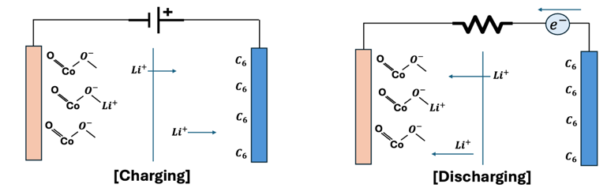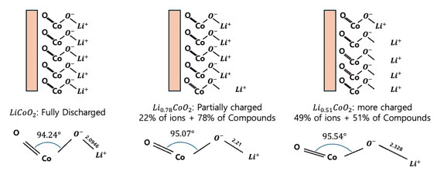
Fig. 1 A Schematic of battery charging and discharging. The red-colored elements represent the cathode, while the blue-colored elements represent the anode. The arrows represent the movement of lithium ions and electrons. B Depending on the oxidation state (denoted as x in LiₓCoO₂) of each compound, the upper figure represents the relative number of lithium ions separated from the cathode, while the lower figure illustrates the average geometry of LiCoO₂.
When a voltage is applied to the anode and cathode to supply electrons (i.e., during charging), the Li⁺ ions migrate to the anode. Upon discharging from this charged state, the Li⁺ ions from the negative electrode recombine with the positive electrode, as shown in the Fig. 1 Left), and current flows through the resistor. During this process, depending on the oxidation state of lithium, the average geometry of the molecular structure changes, as illustrated in Fig. 1 Right). Therefore, the energy stored in the bulk can be estimated using this geometry. The energy of the molecule is calculated by assuming a gas-phase model, which treats the average oxide structure as a single molecule.
  - VQE (Variational Quantum Eigensolver)
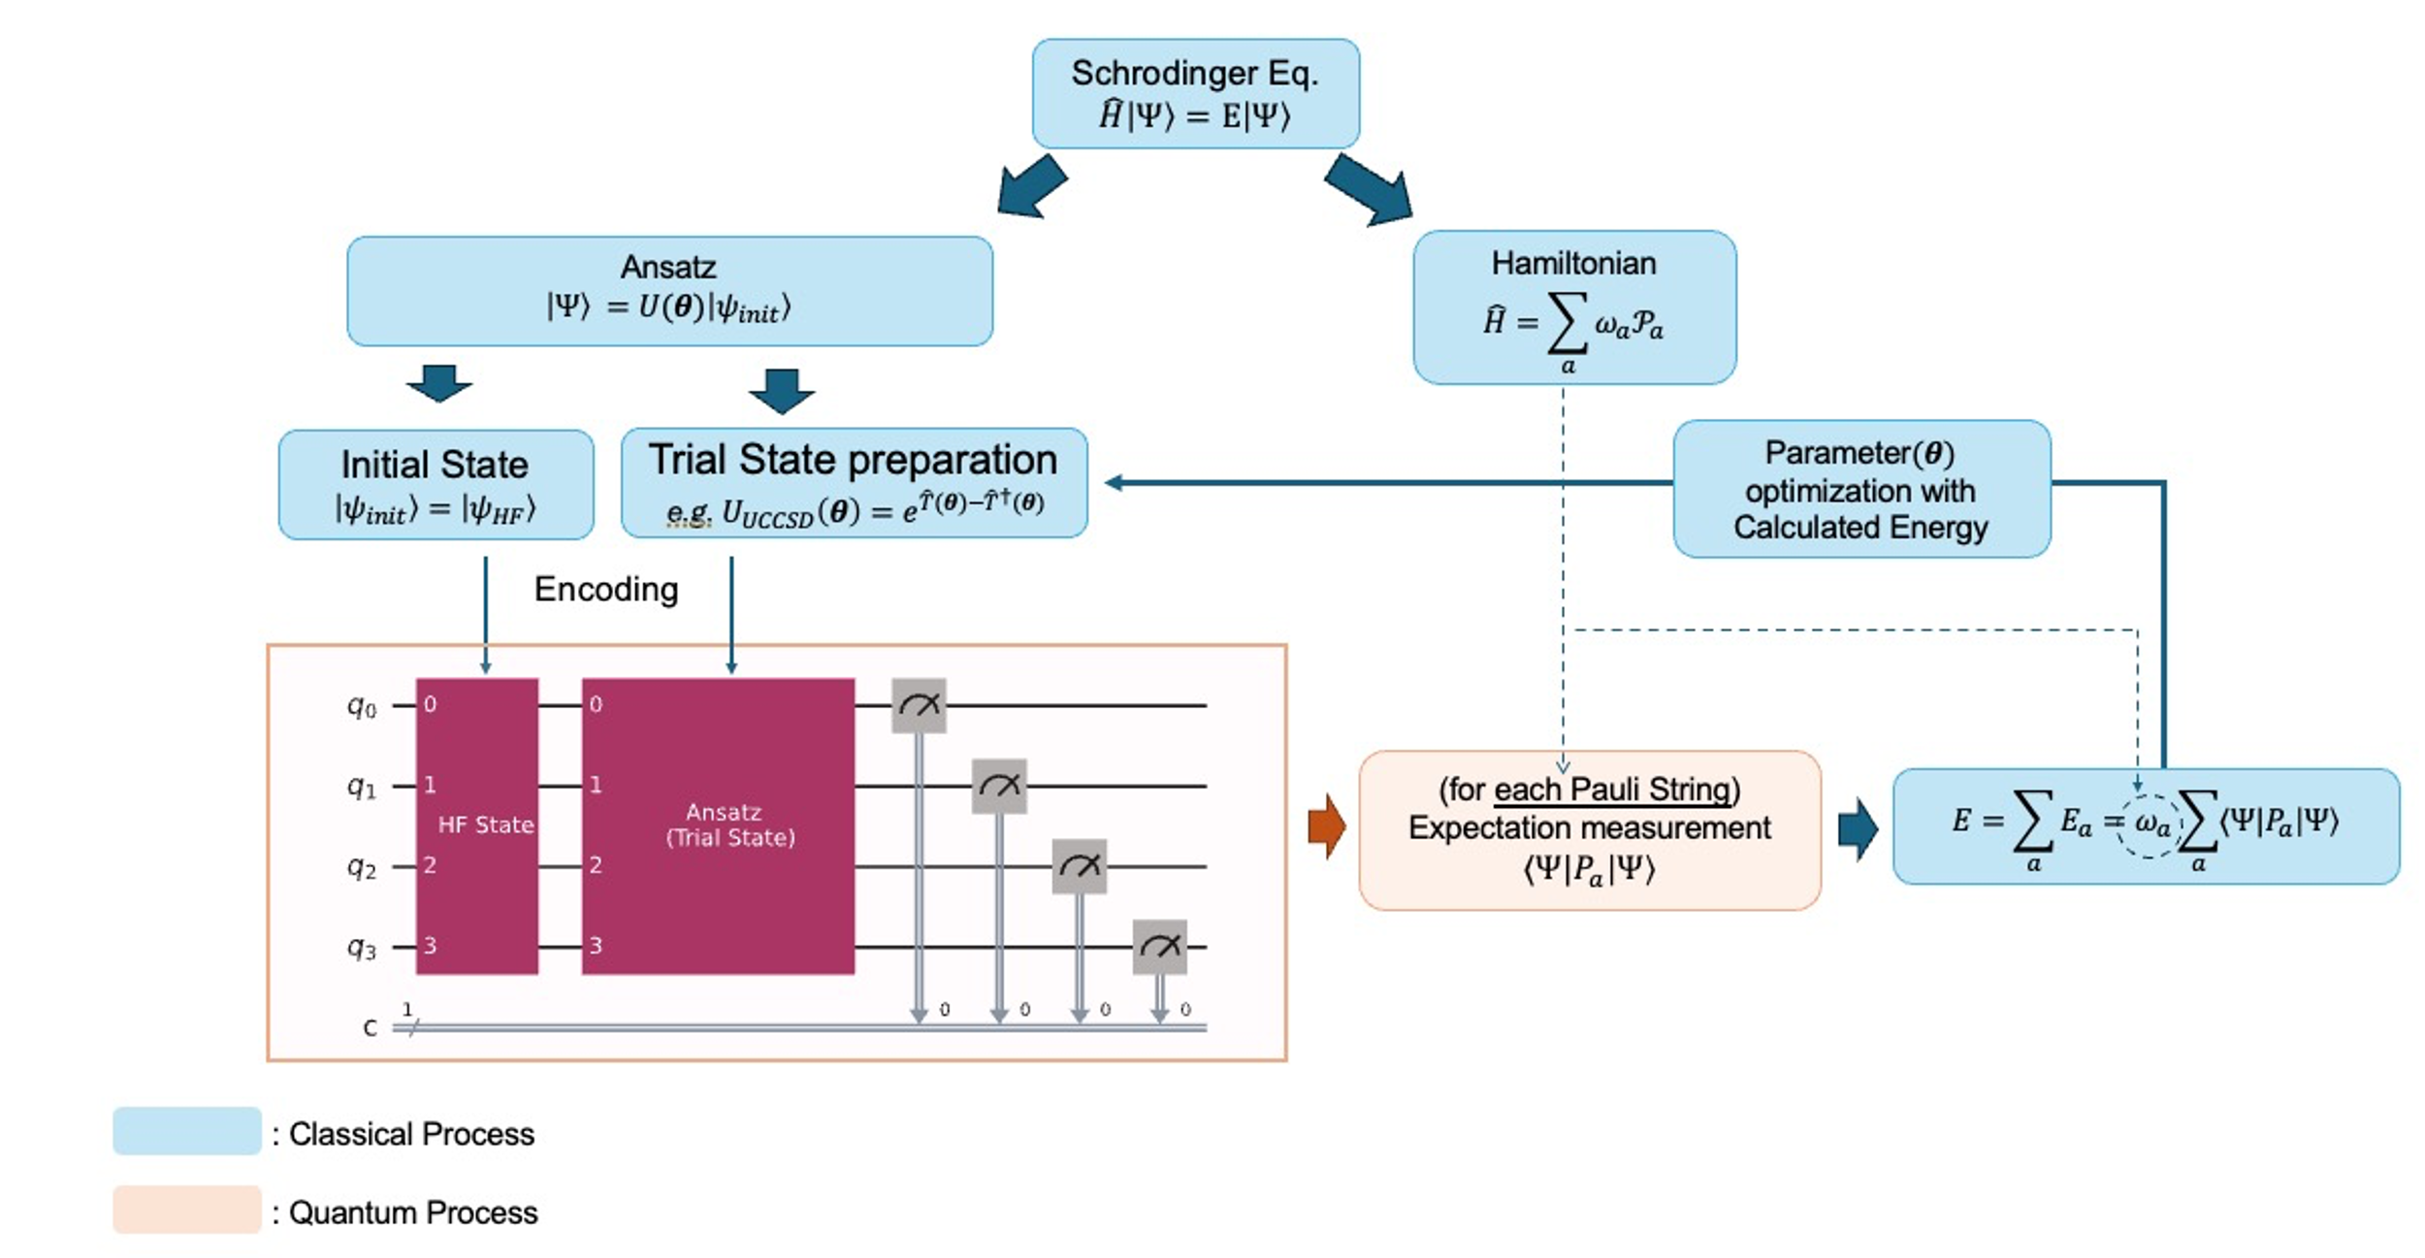
Fig. 2. VQE Pipeline. Starting from the Schrödinger equation of the system, the process involves finding an appropriate measurement basis using the Hamiltonian, constructing an Ansatz to represent an arbitrary state with a parameterized quantum circuit, and finding the ground state energy through the variational method by performing measurements and updating the parameters
The Variational Quantum Eigensolver (VQE) algorithm is an eigenvalue problem-solving method first proposed by Peruzzo et al [18]. It works by computing the energy in Hilbert space, providing an upper bound on the ground state energy according to the variational principle. VQE calculates the ground state energy of a system by measuring the energy on a quantum computer and performing optimization on a classical computer. To measure the energy of a system on a quantum computer, the Hamiltonian must be mapped to a form that can be represented as a quantum circuit. Additionally, an arbitrary quantum state needs to be encoded into the circuit for the measurement process.

Hamiltonian
The Hamiltonian of a molecule is represented by the Electronic Structure Hamiltonian as follows:
${\hat{H}}_{el}(r)=-\sum_{i}{\frac{1}{2}∇_{r_{i}}^{2}-\sum_{I}{\sum_{i}{\frac{Z_{I}}{\left|R_{I}-r_{i}\right|}}}}+\sum_{i}{\sum_{j>i}{\frac{1}{\left|r_{i}-r_{j}\right|}}}$ (1)
where $r_{i}$ denotes the position vector of the $i$-th electron, $R_{I}$ denotes the position of the $I$-th nucleon, and $Z_{I}$ is the atomic number of the $I$-th nucleon. To map this Hamiltonian to the Pauli gates, we express it in second quantized form using fermionic creation/annihilation operators [7-9], as follows:
${\hat{H}}_{el}=\sum_{p,q}{h_{pq}{\hat{a}}_{p}^{†}{\hat{a}}_{q}}+\frac{1}{2}\sum_{p,q,r,s}{h_{pqrs}{\hat{a}}_{p}^{†}{\hat{a}}_{q}^{†}{\hat{a}}_{r}{\hat{a}}_{s}},$ (2)
$where, h_{pq}=\left\langle ϕ_{p}\left|{\hat{H}}_{el}\right|ϕ_{q}\right\rangle , h_{pqrs}=\left\langle ϕ_{p}ϕ_{q}\left|{\hat{H}}_{el}\right|ϕ_{r}ϕ_{s}\right\rangle$ (3)
Fermionic operators can be mapped to Pauli gates using Jordan-Wigner mapping, Parity mapping, and bravyi-kitaev mapping [10, 11]. In this experiment, we will use the Parity mapping method. Parity mapping expresses the creation-annihilation operator through a Pauli gate by corresponding the parity of the $i^{th}$ qubit to the parity of the electron occupancy of the $i^{th}$orbital. In this case, the parity of the α-spin and β-spin of the molecule can be utilized to reduce the number of qubits required by two. The resulting Hamiltonian of the mapping is represented by a Pauli string ($P_{a}$) and its weights or linear coefficients ($ω_{a}$) as shown below.
$\hat{H}=\sum_{a}{ω_{a}P_{a}}$ (4)

Ansatz

To represent arbitrary quantum states, we construct a parameterized quantum circuit (PQC) with linear coefficients corresponding to each basis as parameters. The performance of the ansatz is difficult to evaluate, and it is not known a priori which ansatz is better for different systems. Therefore, in this experiment, we use two different ansatzes to achieve better results.

Two-Local (Efficient SU2) Ansatz

The quantum state of a single qubit is represented by a rotation gate with two arbitrary angles on the Bloch sphere. If the angle of the rotation gate is treated as a parameter, and the entanglement — a property of qubits in a multi-qubit system — is expressed using a CNOT gate, then the quantum state of an arbitrary multi-qubit system can be expressed using these parameters.

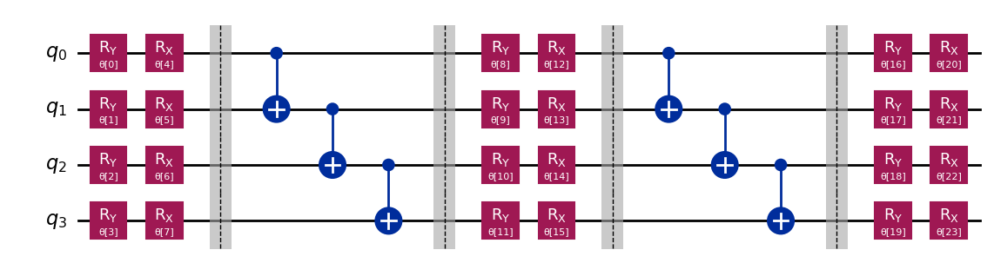
Fig. 3. An example of a Two-Local Ansatz for a 4-Qubit system with 2 repetitions. The regions represented by dashed lines and the gray area distinguish the layers. The regions represented by Rx and Ry gates, which include the parameter θ, represent the "rotation layer", while the regions represented by CNOT gates correspond to the "entanglement layer".

The construction of the Two-Local Ansatz does not require an interpretation of the Hamiltonian. It is a representation of an arbitrary quantum state that is encoded in hardware, making it hardware-efficient.

UCCSD Ansatz
Through second quantization, we express the Hamiltonian operator in terms of the basis of the molecular orbitals of the system. Ultimately, the state we are looking for is represented in the same Hilbert space as the Hamiltonian. By using the same spin-orbitals as the basis, we can express any quantum state in the Hilbert space where the Hamiltonian exists. In this way, the quantum state is expressed through Coupled-Cluster Theory, using the spin-orbital wavefunctions of the molecule as the basis [12, 13]. When considering only second-order excitations, it is represented as a unitary operator, UCCSD (Unitary Coupled-Cluster Singles and Doubles), with the following expression[14]:
$\hat{T}={\hat{T}}_{1}+{\hat{T}}_{2}, \left(Cluster operator\right)$ (5)
$where, {\hat{T}}_{1}=\sum_{i,a}{c_{i}^{a}{\hat{a}}_{a}^{†}{\hat{a}}_{i}}, {\hat{T}}_{2}=\sum_{ijab}{t_{ij}^{ab}{\hat{a}}_{a}^{†}{\hat{a}}_{b}^{†}{\hat{a}}_{j}{\hat{a}}_{i}}$
${\left|Ψ\right\rangle }_{UCCSD}=e^{\hat{T}-{\hat{T}}^{†}}\left|ψ_{ref}\right\rangle$ (6)
The states are represented by creation and annihilation operators, which can be encoded in quantum circuits using either Jordan-Wigner mapping or parity mapping. The energy of the system is calculated by measuring the expectation value for each Pauli string in the Hamiltonian within these quantum circuits. By iterating over these measurements and optimizing the parameters of the ansatz to minimize the calculated energy, an upper bound on the ground state energy is determined. The resulting minimum corresponds to the ground state energy calculated by the VQE algorithm for the system.
  - FMO (Fragmental Molecular orbital)
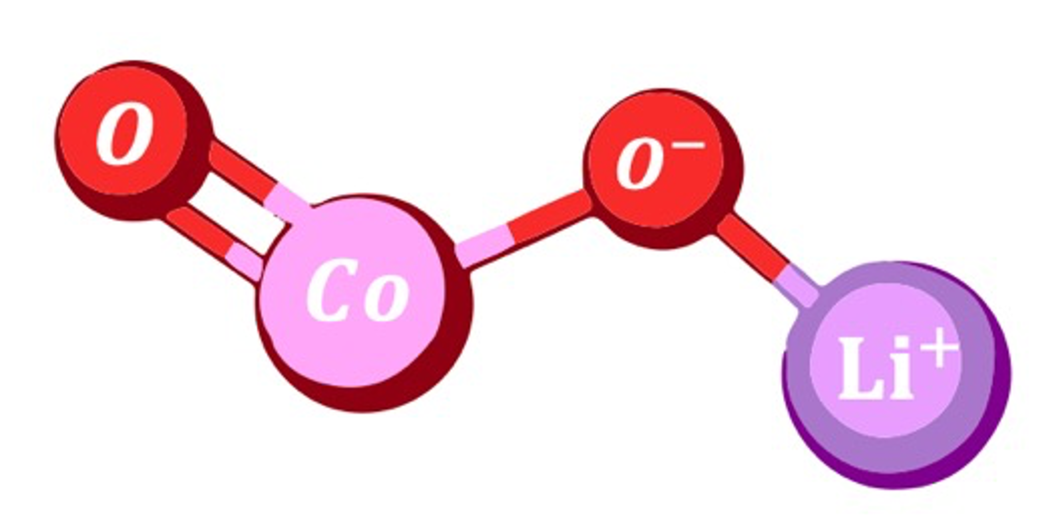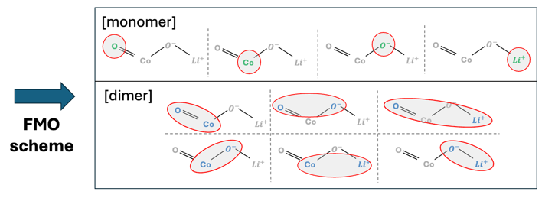
Fig. 4. An example of the FMO scheme in $LiCoO_{2}$
The FMO method is a method that divides a whole molecular system into smaller system fragments and approximates the energy of the whole system by using the energy of one fragment (monomer) and the energy of pairs of fragments (dimers). When calculating the ground state energy of a molecule by the usual method, the computational complexity is exponential in the size of the system. However, the FMO method can effectively reduce the computational complexity by dividing a large system into parts.
The FMO method has two main steps. The first is the FMO-based restricted Hartree-Fock (FMO-RHF) process, which calculates the RHF through the Hamiltonian of monomers and dimers. The Hamiltonian of monomer(${\hat{H}}_{A}$) and the Hamiltonian of dimer(${\hat{H}}_{AB}$) are as follows.
${\hat{H}}_{A}=\sum_{i∈A}{\left[-\frac{∇_{r_{i}}^{2}}{m_{e}}-\sum_{I}{\frac{Z_{I}}{\left|r_{i}-R_{I}\right|}}+\sum_{ C≠A}^{N_{tot}}{∫dr^{'}\frac{ρ_{J}\left(r^{'}\right)}{\left|r_{i}-r^{'}\right|}}\right]}+\sum_{i∈A}{\sum_{i<j∈A}{\frac{1}{\left|r_{i}-r_{j}\right|}}}$ (7)
${\hat{H}}_{AB}=\sum_{i∈A,B}{\left[-\frac{∇_{r_{i}}^{2}}{m_{e}}-\sum_{I}{\frac{Z_{I}}{\left|r_{i}-R_{I}\right|}}+\sum_{C≠A,B}^{N_{tot}}{∫dr^{'}\frac{ρ_{J}\left(r^{'}\right)}{\left|r_{i}-r^{'}\right|}}\right]}+\sum_{i∈A,B}{\sum_{i<j∈A,B}{\frac{1}{\left|r_{i}-r_{j}\right|}}}$ (8)
(Where A,B are the respective fragments. C refers to the fragments that are not included in monomer A or dimer AB, and the term $ρ_{J}\left(r^{'}\right)$ is the electric charge density of the fragments outside the monomer or dimer.) By calculating the RHF of each monomer and dimer through the Hamiltonian above, we can get $E^{FMO-RHF}$, which can be expressed as follows.
$E^{FMO2-RHF}=E^{FMO1-RHF}+ΔE^{FMO2-RHF}$ (9)
$E^{FMO1-RHF}=\sum_{A}^{N}{E_{A}}$ (10)
$ΔE^{FMO2-RHF}=\sum_{A>B}^{N}{\left[E_{IJ}-E_{I}-E_{J}\right]}$ (11)
In the above equations, N refers to all fragments. From the above equations, we can get the HF energy including the electrostatic potential of the whole molecule. The next step is to proceed with FMO based coupled-cluster (FMO-CC). This process is performed to obtain a more accurate value of the FMO-RHF energy, and since this process does not include the electrostatic potential, the Hamiltonian can be calculated using the Electronic Structure Hamiltonian defined earlier. The process of calculating the total energy ($E^{FMO-CC}$) and correlation energy ($E^{FMO-corr}$) obtained through FMO-CC is as follows.
$E^{FMOn-CC}=E^{FMOn-RHF}+E^{FMOn-corr}$ (12)
$E^{FMO2-corr}=E^{FMO1-corr}+ΔE^{FMO2-corr}$ (13)
$E^{FMO1-corr}=\sum_{A}^{N}{E_{I}^{corr}}$ (14)
$ΔE^{FMO2-corr}=\sum_{A>B}^{N}{\left(E_{IJ}^{corr}-E_{J}^{corr}-E_{I}^{corr}\right)}$ (15)
In the above, the FMO-RHF and FMO-CC processes should be separated because the Hamiltonian used in the two processes may be different, and the FMO-CC process should proceed after the SCF calculation of FMO-RHF converges. However, in this experiment, the electrostatic potential term in the FMO-RHF Hamiltonian was approximated by ignoring it, so each process was carried out consecutively and the total energy was calculated from the obtained monomer and dimer energies as follows.
  - FMO-VQE (Fragment molecular orbital-based Varational Quantum Eigensolver)
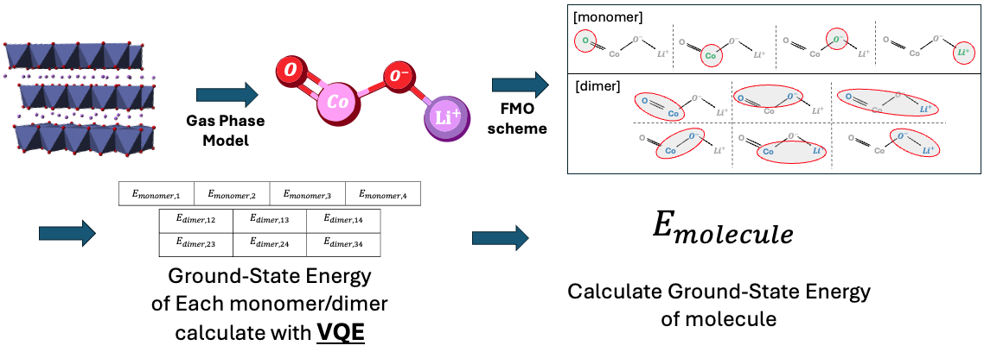
Fig. 5. An illustration of applying the FMO/VQE method. 1) the LiCoO₂ compound in the cathode material forms a layered structure, However, assuming a gas-phase model, it is considered that a single compound exists as a molecule. 2) The FMO scheme is applied to form monomers and dimers. 3) The ground state energy of each fragment is calculated using VQE. 4) The ground state energy of the entire molecule is then calculated using the energies of each fragment.
FMO-VQE is an algorithm first introduced by Lim et al. that combines the VQE algorithm with the FMO method. In the VQE algorithm, the Hamiltonian is represented based on the molecular spin-orbitals, so it requires as many qubits as the number of molecular spin-orbitals. However, the number of qubits is currently limited, so the number of molecules that can be simulated in the existing VQE algorithm is limited. However, if the FMO Method is applied to the existing VQE algorithm, the number of qubits required for a single calculation can be reduced by parallelizing the calculation and simulating the total system in pieces.
Let's compare the number of qubits required with and without the FMO method. Both calculations use Active Space to reduce the number of qubits required [15, 16]. Given the dynamics of the system, excitations in the core orbital of each atom will have a smaller probability than excitations in the valence orbital. Therefore, we will calculate the core orbital, which is less likely to be involved in bonding, as a separate constant, and assume that the space spanned by the wavefunction of the valence orbital of each atom is a Hilbert space. Under these assumptions, the number of qubits required for a conventional VQE calculation is as follows. (Table 1.)
Table 1. Orbital structure of each atom
atom | Number of Valence orbital | Number of Valence electron
$$Li$$ | 2 | 1
$$O$$ | 6 | 8
$$Co$$ | 10 | 7
Table 2. Orbital structure of each Fragment
Configuration | Number of Valence orbital | Number of Valence electron
monomer
$$Li$$ | 2 | 1
$$O$$ | 6 | 4
$$Co$$ | 10 | 7
Dimer
$$Li-O$$ | 6 | 5
$$Li-Co$$ | 12 | 8
$$O-O$$ | 12 | 8
$$Co-O$$ | 16 | 11
Therefore, the number of spin-orbitals required for the VQE calculation is 24, considering that oxygen has 2. If we use the parity mapper here, we can reduce the number of qubits needed for the calculation by 2, so 22 qubits are needed to solve this system via conventional VQE.
Let's apply the FMO method, where each atom is a fragment, which means that 4 monomers are created and 6 dimer systems need to be calculated. The number of spin-orbitals required for each calculation is shown below (only one is shown for configurations with the same composition).
Therefore, the maximum number of qubits required in the calculation is 14 (using Parity mapper). By applying the FMO method, we can reduce the number of qubits required for the calculation by 8. Furthermore, the potential of this method is in larger systems. When simulating larger molecules such as Ni, Mn, etc. added to the popular $LiCoO_{2}$ molecule, conventional VQE requires more qubits than the number of valence orbitals of those atoms. However, in FMO-VQE, the increase in the size of the system leads to an increase in the number of fragments, so it is possible to calculate the energy of larger molecules using the same number of qubits.
- Result
  - Monomer/Dimer Energy
Table 3. Energy of Monomer for each Ansatz/Optimizer
System | UCCSD |  |  | Two-Local
System | COBYLA | SPSA | L-BFGS-B | COBYLA | SPSA | L-BFGS-B
“Li” | -7.315526 | -7.315526 | -7.315526 | -7.315526 | -7.315430 | -7.315526
“O” | -73.804150 | -73.804150 | -73.804150 | -73.804150 | -73.803074 | -73.804150
“Co” | -1365.943920 | -1366.002044 | -1366.118261 | -1366.006785 | -1365.740246 | -1366.092075
Table 4. Energy of Dimer for each Ansatz/Optimizer for each Oxidation State of $Li_{x}CoO2$
[x=1] | UCCSD |  |  | Two-Local
Configuration | COBYLA | SPSA | L-BFGS-B | COBYLA | SPSA | L-BFGS-B
“Li-O¹” | -81.036530 | -81.062982 | -81.069739 | -81.023626 | -80.978418 | -81.069703
“Li-O²” | -81.117531 | -81.117951 | -81.117956 | -81.094238 | -81.030553 | -81.117577
“Li-Co” | -1373.429758 | -1373.567946 | -1373.618739 | -1373.576316 | -1373.512522 | -1373.609970
“O-O” | -147.432250 | -147.485749 | -147.599156 | -147.528891 | -147.334234 | -147.605860
“Co-O¹” | -1439.355819 | -1439.796790 | -1439.957262 | -1439.315189 | -1439.321781 | -1439.695408
“Co-O²” | -1439.459214 | -1439.788926 | -1439.888880 | -1439.396154 | -1439.727786 | -1439.918488

[x=0.94] | UCCSD |  |  | Two-Local
Configuration | COBYLA | SPSA | L-BFGS-B | COBYLA | SPSA | L-BFGS-B
“Li-O¹” | -81.079066 | -81.071382 | -81.084085 | -81.014315 | -81.042272 | -81.084060
“Li-O²” | -81.119992 | -81.119699 | -81.120071 | -81.117758 | -81.066772 | -81.120071
“Li-Co” | -1373.434678 | -1373.568648 | -1373.569509 | -1373.347301 | -1373.529010 | -1373.584236
“O-O” | -147.391974 | -147.374393 | -147.608042 | -147.551759 | -147.523597 | -147.489992
“Co-O¹” | -1439.423661 | -1439.843317 | -1439.952027 | -1439.169880 | -1439.485884 | -1439.803393
“Co-O²” | -1439.393635 | -1439.485720 | -1439.898848 | -1439.210821 | -1439.564247 | -1439.986058

[x=0.78] | UCCSD |  |  | Two-Local
Configuration | COBYLA | SPSA | L-BFGS-B | COBYLA | SPSA | L-BFGS-B
“Li-O¹” | -81.074588 | -81.076294 | -81.086310 | -81.070688 | -81.021452 | -81.086299
“Li-O²” | -81.118325 | -81.119637 | -81.120088 | -81.097025 | -81.058402 | -81.119684
“Li-Co” | -1373.206240 | -1373.319480 | -1373.354329 | -1373.591995 | -1373.380891 | -1373.725492
“O-O” | -147.412124 | -147.551726 | -147.607067 | -147.517407 | -147.166796 | -147.560823
“Co-O¹” | -1439.226044 | -1439.778362 | -1439.840047 | -1439.319849 | -1439.523202 | -1439.714842
“Co-O²” | -1439.547179 | -1439.828032 | -1439.944688 | -1439.300309 | -1439.408856 | -1439.738547

[x=0.75] | UCCSD |  |  | Two-Local
Configuration | COBYLA | SPSA | L-BFGS-B | COBYLA | SPSA | L-BFGS-B
“Li-O¹” | -81.065682 | -81.081421 | -81.086310 | -81.003117 | -81.023070 | -81.012210
“Li-O²” | -81.119826 | -81.120074 | -81.120088 | -81.095257 | -81.071903 | -81.120088
“Li-Co” | -1373.223660 | -1373.354256 | -1373.328463 | -1373.589681 | -1373.585003 | -1373.790507
“O-O” | -147.413053 | -147.281268 | -147.607526 | -147.445853 | -147.442307 | -147.462992
“Co-O¹” | -1439.226044 | -1439.778362 | -1439.840047 | -1439.319849 | -1439.523202 | -1439.714842
“Co-O²” | -1439.388348 | -1439.758178 | -1439.857075 | -1439.354511 | -1439.479002 | -1439.722998

[x=0.66] | UCCSD |  |  | Two-Local
Configuration | COBYLA | SPSA | L-BFGS-B | COBYLA | SPSA | L-BFGS-B
“Li-O¹” | -81.053296 | -80.984815 | -81.084085 | -81.014315 | -81.042272 | -81.084060
“Li-O²” | -81.119992 | -81.119699 | -81.120071 | -81.117758 | -81.066772 | -81.120071
“Li-Co” | -1373.434678 | -1373.568648 | -1373.569509 | -1373.347301 | -1373.529010 | -1373.584236
“O-O” | -147.391974 | -147.374393 | -147.608042 | -147.551759 | -147.523597 | -147.489992
“Co-O¹” | -1439.423661 | -1439.843317 | -1439.952027 | -1439.169880 | -1439.485884 | -1439.803393
“Co-O²” | -1439.393635 | -1439.485720 | -1439.898848 | -1439.210821 | -1439.564247 | -1439.986058
*All values in the Table 3, Table 4 are in $Ha$ units. The underlined values represent the lowest energy convergence values for each configuration. The configurations with superscripts refer to different dimers with the same composition but different geometric structures(The geometric structure refers to [17]).
Li-O¹: A dimer consisting of O and Li atoms that form a bond.
Li-O²: A dimer consisting of O and Li atoms that do not form a bond.
Co-O¹: A dimer consisting of Co and O atoms forming a single bond.
Co-O²: A dimer consisting of Co and O atoms forming a double bond.

Table 3, Table 4 present the VQE calculation results for each monomer and dimer of the LiCoO₂ molecule, divided into fragments. A total of six cases were computed, combining two types of Ansatz and three types of optimizers. Under the conditions of this experiment, the energy of the monomer does not depend on the relative coordinates of each fragment and is therefore independent of the molecular geometry. In other words, even if the oxidation state changes, the calculation results remain the same, meaning the calculation only needs to be performed once.
Regarding optimizer selection, the difference between L-BFGS-B and other optimizers is approximately on the order of 0.1 Ha. This represents a significant error compared to the desired precision. While COBYLA and SPSA are much faster in terms of computation time, L-BFGS-B demonstrates better results when precision is prioritized.
Several configurations are noteworthy when selecting an Ansatz. For the Co-O1 and Li-O1 configurations, the UCCSD Ansatz consistently produced the lowest energy values across all calculations. In contrast, for the Li-Co configuration, the Two-Local Ansatz showed better convergence values than UCCSD for oxidation states other than x=1. However, for configurations such as Co-O2, Li-O, and O-O, the optimal Ansatz varied despite identical fragment structures in each oxidation state. For instance, in the results for Co-O2, the lowest energies were achieved with UCCSD at x=0.78 and x=0.75, while Two-Local outperformed UCCSD at x=1.00, x=0.94, and x=0.66. This suggests that even for systems with similar characteristics, the choice of Ansatz that best represents the system can vary depending on the specific configuration.
The choice of Ansatz ultimately determines how the Hilbert space is represented in each basis. When the space represented by spin-orbitals is not large, the difference between different Ansatz selections is minimal. However, as the dimension of the Hilbert space increases, the expressive power of different Ansatz types can diverge significantly.
For systems such as Li-O¹ and Li-O² which are represented using approximately 8 spin-orbital wavefunctions as the basis, the energy difference between Ansatz is typically on the order of ${10}^{-3}Ha$, which is relatively small. However, as the system size grows, the difference becomes more pronounced. For example, in systems like Li-Co and O-O² represented by 12 spin-orbital wavefunctions, or Co-O¹ and Co-O² represented by 16 spin-orbital wavefunctions, the difference increases to the order of ${10}^{-1} Ha$. Such differences can significantly impact the precision of the calculated values. Therefore, the choice of Ansatz can have a substantial impact depending on the system, especially for experiments requiring high precision. It is crucial to evaluate multiple Ansatz and select the optimal one for each specific system to ensure the best possible results.

  - Molecular Energy
The $E_{FMO/VQE}$values in Table 5, 6 represent the ground-state energies of $Li_{x}CoO_{2}$for each oxidation state($x$), calculated using the FMO-VQE methodology proposed in this paper. The $E_{FCI}$and $E_{CCSD}$values are obtained using the traditional computational chemistry methods with the GAMESS simulator, corresponding to the Full Configuration Interaction (FCI) and Coupled-Cluster with Single and Double excitations (CCSD) methods, respectively. In the FCI calculations, the Active Core Scheme was used, whereas it was not used in the CCSD calculations. The energy values represent the results obtained from these classical simulation methods, and the error refers to the difference between the FMO-VQE calculation results and those obtained from the traditional methods. Additionally, the accuracy is expressed as the percentage of this error relative to the traditional energy values.
First, let us examine the results of VQE and FCI calculations. FCI is considered the most accurate theoretical calculation method and is often used as a reference value in many chemical calculations. In this experiment, both VQE and FCI used the same Active Core Scheme to approximate the system before calculating the energy, and it was confirmed that the VQE algorithm produced energy values very similar to those obtained from FCI. The smallest error was observed at $x=0.94$, where the error was $-0.005892$, resulting in a lower energy value compared to FCI, indicating that the VQE algorithm is highly accurate. On the other hand, at $x=0.66$ the error was $0.086063$, and at $x=1$ the error was $0.040462$, showing a relatively larger difference.
Table 5. Comparison of the energy, error, and accuracy between FMO/VQE and FCI. Where $Error=E_{FMO/VQE}-E_{FCI}$ and $Accuracy=\left|100×Error/E_{FCI}\right|$
Oxidation  Number  ($Li_{x}CoO_{2}$) | $$E_{FMO/VQE}$$ | $$E_{FCI}$$ | Error | Accuracy(%)
1.00 | -1521.203868 | -1521.244330 | 0.040462 | 99.9973
0.94 | -1521.250344 | -1521.244451 | -0.005892 | 99.9996
0.78 | -1521.239517 | -1521.247824 | 0.008307 | 99.9995
0.75 | -1521.217377 | -1521.248807 | 0.031431 | 99.9979
0.66 | -1521.163133 | -1521.249196 | 0.086063 | 99.9943
Table 6. Comparison of the energy, error, and accuracy between FMO/VQE and CCSD. Where $Error=E_{FMO/VQE}-E_{CCSD}$ and $Accuracy=\left|100×Error/E_{CCSD}\right|$
Oxidation  Number  ($Li_{x}CoO_{2}$) | $$E_{FMO/VQE}$$ | $$E_{CCSD}$$ | Error | Accuracy(%)
1.00 | -1521.203868 | -1521.342101 | 0.138232 | 99.9884
0.94 | -1521.250344 | -1521.338869 | 0.088525 | 99.9919
0.78 | -1521.239517 | -1521.341358 | 0.101841 | 99.9933
0.75 | -1521.217377 | -1521.340712 | 0.123336 | 99.9942
0.66 | -1521.163133 | -1521.340283 | 0.177150 | 99.9909
B
A
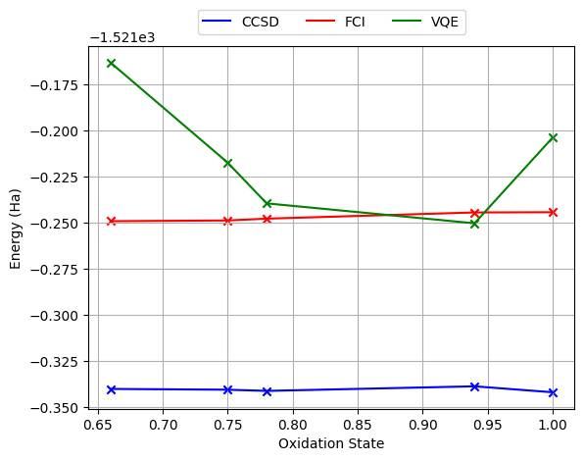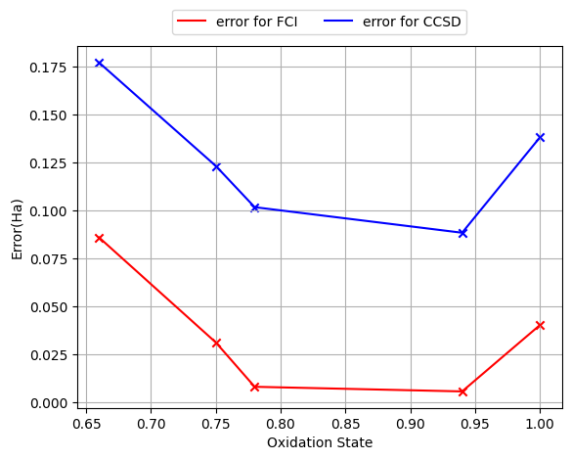
Fig. 6 A Energy of FMOVQE, FCI, and CCSD for each oxidation state. CCSD (blue) and FCI (red) are Energies of calculated using classical simulators, while FMOVQE (green) represents the Energies calculated using the FMO-VQE algorithm proposed in this study. B The blue graph represents the absolute error between Energy of FMOVQE and CCSD, while the red graph represents the absolute error between Energy of FMOVQE and FCI.
Next, we compare VQE, FCI, and CCSD. FCI is generally regarded as the most precise calculation method and typically provides lower energy convergence values than CCSD. However, in this study, CCSD calculated energy values that were approximately 0.1 Ha lower than FCI for all oxidation states. This difference is attributed to the application of the Active Core Scheme. While FCI employed the Active Core Scheme, CCSD performed calculations on the entire molecule, leading to lower energy values.
By comparing the FMO-VQE algorithm with FCI, we found that the precision of FMO-VQE closely matches that of FCI. This suggests that the FMO-VQE method achieves an accuracy comparable to that of traditional computational methods, demonstrating that quantum computing can deliver practical levels of accuracy. This result implies that, with further advancements in quantum computing technology, it could offer more efficient and accurate calculations than traditional computational chemistry methods. Therefore, this work suggests that the FMO-VQE method provides accuracy nearly identical to classical methods and, with future improvements in quantum computing, could potentially achieve even higher precision. This represents a significant advancement in chemical calculations using quantum computing, showing that it may enable faster and more precise predictions than existing classical methods.

- Conclusions
As is well known, the current limitations of quantum computers, particularly in terms of available qubits, make it challenging to apply the Variational Quantum Eigensolver (VQE) to large and complex molecules in industrial applications. To overcome this limitation, we propose the use of the FMO-VQE approach for real-world problems. In this study, we evaluated the ground-state energy of LiCoO₂ using the FMO-VQE method and demonstrated that the number of required qubits can be reduced from 24 to a maximum of 14. This reduction highlights the ability of the FMO-VQE quantum algorithm to accurately calculate the ground-state energy of the LiₓCoO₂ molecule with high precision, even with a significantly reduced qubit count compared to classical simulations. Classical computing methods are increasingly insufficient for handling the complexity of molecules involved in drug synthesis and new material development. The FMO-VQE algorithm, as demonstrated in this study, reduces the number of qubits needed for these calculations by leveraging the FMO method. Our results thus underscore the potential of FMO-VQE to facilitate advancements in drug synthesis and the development of novel materials, marking a promising step toward practical quantum computing applications in these fields.

1. Li, G., Zhou, S., Wang, P., Zhao, J.: Halogen-doping in licoo 2 cathode materials for li-ion batteries: Insights from ab initio calculations. RSC advances 5, 107326-107332 (2015).
2. Lyu, Y., Wu, X., Wang, K., Feng, Z., Cheng, T., Liu, Y. et al.: An overview on the advances of licoo2 cathodes for lithium‐ion batteries. Advanced Energy Materials 11, 2000982 (2021).
3. Mizushima, K., Jones, P. C., Wiseman, P. J., Goodenough, J. B.: Lixcoo2 (0< x<-1): A new cathode material for batteries of high energy density. Materials Research Bulletin 15, 783-789 (1980).
4. Tabelin, C. B., Dallas, J., Casanova, S., Pelech, T., Bournival, G., Saydam, S. et al.: Towards a low-carbon society: A review of lithium resource availability, challenges and innovations in mining, extraction and recycling, and future perspectives. Minerals Engineering 163, 106743 (2021).
5. Tarascon, J.-M., Armand, M.: Issues and challenges facing rechargeable lithium batteries. nature 414, 359-367 (2001).
6. He, W., Guo, W., Wu, H., Lin, L., Liu, Q., Han, X. et al.: Challenges and recent advances in high capacity li‐rich cathode materials for high energy density lithium‐ion batteries. Advanced Materials 33, 2005937 (2021).
7. Fermann, J. T., Valeev, E. F.: Fundamentals of molecular integrals evaluation. arXiv preprint arXiv:2007.12057, (2020).
8. Jørgensen, P., Second quantization-based methods in quantum chemistry. (Elsevier, 2012).
9. Stewart, R. F.: Small gaussian expansions of slater‐type orbitals. The Journal of Chemical Physics 52, 431-438 (1970).
10. Seeley, J. T., Richard, M. J., Love, P. J.: The bravyi-kitaev transformation for quantum computation of electronic structure. The Journal of chemical physics 137, (2012).
11. Tranter, A., Love, P. J., Mintert, F., Coveney, P. V.: A comparison of the bravyi–kitaev and jordan–wigner transformations for the quantum simulation of quantum chemistry. Journal of chemical theory and computation 14, 5617-5630 (2018).
12. Bartlett, R. J., Musiał, M.: Coupled-cluster theory in quantum chemistry. Reviews of Modern Physics 79, 291-352 (2007).
13. Crawford, T. D., Schaefer III, H. F.: An introduction to coupled cluster theory for computational chemists. Reviews in computational chemistry 14, 33-136 (2007).
14. Lee, J., Huggins, W. J., Head-Gordon, M., Whaley, K. B.: Generalized unitary coupled cluster wave functions for quantum computation. Journal of chemical theory and computation 15, 311-324 (2018).
15. Olsen, J.: The initial implementation and applications of a general active space coupled cluster method. The Journal of Chemical Physics 113, 7140-7148 (2000).
16. Piecuch, P.: Active-space coupled-cluster methods. Molecular Physics 108, 2987-3015 (2010).
17. Hertz, J. T., Huang, Q., Mcqueen, T., Klimczuk, T., Bos, J., Viciu, L. et al.: Magnetism and structure of li x co o 2 and comparison to na x co o 2. Physical Review B—Condensed Matter and Materials Physics 77, 075119 (2008).

